This document is merely to point out the differences in confessional count numbers between my findings and the official numbers posted on Survivor Sucks. The guidelines I use can be found [here](https://docs.google.com/document/d/18ofsPiVWxSejzSjEGlU8KEx4Og2ddEJScCV23RsCPIA/edit?usp=sharing).

**Survivor Sucks Season 09 Counts** ([link](https://goo.gl/photos/5FcsAA7bot9XRC3n9))

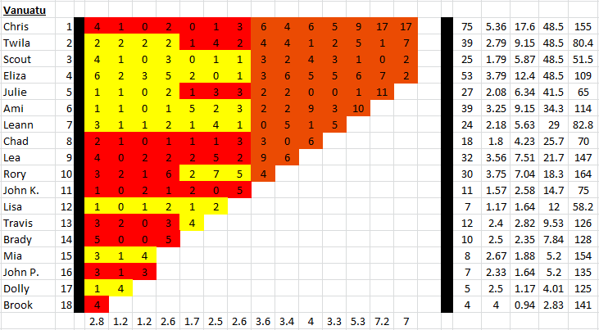

**My Season 09 Counts** ([link](https://goo.gl/photos/8jYVhkf9fVX1waZr5))

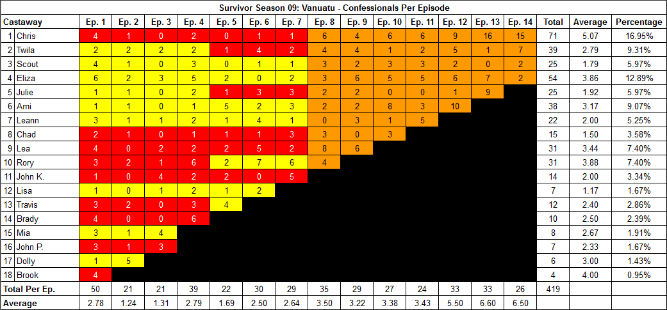

[Survivor Sucks Season 09 thread](http://survivorsucks.com/sreply/287265/S9-Edgic-Editing-and-Logic#.Vu3w3kfpxtF).

**Differences**

[Episode 01](https://docs.google.com/document/d/108q4OlZFrb3wDYpLkAyk4QEhKjDiuE_nTArCRP-dRU0/edit?usp=sharing)

* **Brady:** **4 (-1)** No significant time gap in confessionals.

[Episode 02](https://docs.google.com/document/d/1lGjesH-bg5IUiVx1IrnIQMSB9Hl0rL-UCqf3_oJL-W8/edit?usp=sharing)

* **Dolly:** **5 (+1)** The shortest gap I recorded was a 15s gap between confessionals #6 and #7. Gap between confessionals #18 and #19 is over 15s.

[Episode 03](https://docs.google.com/document/d/14u2iOJvEbvbFdglTWZmK6l-ctOd02DEuIZEPlW3z1T4/edit?usp=sharing)

* **John K:** **4 (+2)** He has 3 consecutive confessionals (#15, #16, #17) but all gaps between them are over 15s.

[Episode 04](https://docs.google.com/document/d/1ToVocHj3bUG7WVnWGzc6Qyp6TnC8eY062wpTYtWEN_c/edit?usp=sharing)

* **John K:** **2 (+1)** Has 2 consecutive confessionals (#5, #6) but the gap is over 15s.
* **Brady:** **6 (+1)** Brady has various consecutive confessionals.
  + > 15s between confessionals #7 and #8.
  + 12s gap between confessionals #30 and #31.
  + 14s gap between confessionals #31 and #32. Also, confessional #32 is a voice over.
* **Note:** Confessional #9, which constitutes Travis’ first confessional out of 3, comes right after Brady is done fishing. Bubba is sitting at camp and talks directly to the camera. It may appear to be an “on the fly” confessional and some may disregard it. If so, it would bring his count down to 2. However, because I counted it, his count remains at 3 as it was originally.

[Episode 07](https://docs.google.com/document/d/1rdrsiDuFYE-cPN9fyJuIuTYllWwO4wf4D50rq_3Y97A/edit?usp=sharing)

* **Chris:** **1 (-2)** Not sure where the other 2 confessionals for him came from.
* **Eliza:** **2 (+1)** Has 2 consecutive confessionals (#6, #7) but the gap is over 15s. Also, confessional #6 has a 9s gap in it.
* **Rory:** **6 (+1)** Has 3 pairs of consecutive confessionals (#4, #5, #12, #13, #21, #22) but all gaps are over 15s.

[Episode 08](https://docs.google.com/document/d/1PJ1JNlT8vzf_yJSxVcLLZ2fdKAE0ZZLWWc1C00pfkBE/edit?usp=sharing)

* **Lea:** **8 (-1)** Confessional #5 has a 9s gap.

[Episode 09](https://docs.google.com/document/d/1x4en9niTdDfvvBE9OdpaOAgRSE04bVNaNnIkMkN7gDs/edit?usp=sharing)

* **Leann:** **3 (-2)** Confessional #8 has two 9s gaps in it.

[Episode 10](https://docs.google.com/document/d/1dxCWImA9LBcUsbDs3on8k76Y4DhJ3K_uNOd0Edl1LVM/edit?usp=sharing)

* **Scout:** **3 (-1)** Confessional #2 has a 9s gap
* **Ami:** **8 (-1)** Not sure where the extra confessional came from.
* **Chad:** **3 (-3)** Confessional #12 has a 9s gap. Not sure where the other 2 confessionals came from.

[Episode 11](https://docs.google.com/document/d/1W3GCghG7pLnFLEMzCLh3rS9lSEJMgLzl7Co1VJW2gFo/edit?usp=sharing)

* **Chris: 6 (+1)** Two consecutive confessionals (#16, #17) with 13s gap in between.

[Episode 12](https://docs.google.com/document/d/1Msitaq3z0TIyD4kz386gip0r8RkdEuvbtugx83SkZVQ/edit?usp=sharing)

* **Scout: 2 (+1)** Two clear confessionals with #12 and #21.

[Episode 13](https://docs.google.com/document/d/1sKzd4MfeB8Gg7L3jBDaKmj-At6-lgMwHxsWDsKJjtjg/edit?usp=sharing)

* **Chris: 16 (-1)** Confessional #11 is a voice over. Gap between confessionals #15 and #16 is 10s. No 9s gaps.
* **Julie: 9 (-2)** Confessional #13 has a 9s gap. Confessional #17 is a voice ver.

[Episode 14](https://docs.google.com/document/d/10cXCOa1KbG_WeIJKhTon_pHN3XkNaQidBj4Fu4xjBu0/edit?usp=sharing)

* **Chris: 15 (-2)** Confessional #4 has a 9s gap.

**No Change**

* [Episode 05](https://docs.google.com/document/d/1RRQUaFkxiI4H8ysVVsTvZdoMYaU_Yo7Mxn62OS5ODho/edit?usp=sharing)
* [Episode 06](https://docs.google.com/document/d/1DijRGKvTHFmHR4SP9WygE9oL4VIrqMTGGlQosreIK20/edit?usp=sharing)

|  |  |  |
| --- | --- | --- |
| **Castaway** | **Count** | **Change** |
| Dolly | 6 | (+1) |
| John K. | 14 | (+3) |
| Rory | 31 | (+1) |
| Lea | 31 | (-1) |
| Chad | 15 | (-3) |
| Leann | 22 | (-2) |
| Ami | 38 | (-1) |
| Julie | 25 | (-2) |
| Eliza | 54 | (+1) |
| Chris | 71 | (-4) |
| **Total** | **419** | **(-7)** |

**Note:** Brady and Scout have no overall change in total count, but they do have different counts on various episodes.

**Revised Sucks Counts** ([link](https://goo.gl/photos/t94KoncFfajzaUuL6))

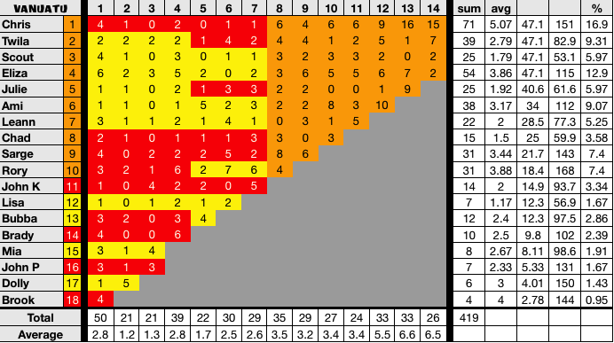

**Differences:** None. All my findings are reflected in the verified counts.